**MINI PROJECT – II**

**2019**

**Customer Assistant Robot**

**SYSTEM REQUIRMENT AND SPECIFICATION**



**Institute of Engineering & Technology**

**Team Members :**

Prakhar Srivastav (161500391)

Subrat Mishra (161500567)

Kushagra Mishra (161500294)

Kumar Ujjwal Pandey (161500290)

Govind Chaudhary (161500218)

**Supervised By-**

**Mr. Amir Khan**

Assistant professor

Department of Computer Engineering & Applications

Table of Contents

Table of Contents ii

Revision History ii

1. Introduction 1

1.1 Purpose 1

1.2 Document Conventions 1

1.3 Intended Audience and Reading Suggestions 1

1.4 Product Scope 1

1.5 References 1

2. Overall Description 2

2.1 Product Perspective 2

2.2 Product Functions 2

2.3 User Classes and Characteristics 2

2.4 Operating Environment 2

2.5 Design and Implementation Constraints 2

2.6 User Documentation 2

2.7 Assumptions and Dependencies 3

3. External Interface Requirements 3

3.1 User Interfaces 3

3.2 Hardware Interfaces 3

3.3 Software Interfaces 3

3.4 Communications Interfaces 3

4. System Features 4

4.1 System Feature 1 4

4.2 System Feature 2 (and so on) 4

5. Other Nonfunctional Requirements 4

5.1 Performance Requirements 4

5.2 Safety Requirements 5

5.3 Security Requirements 5

5.4 Software Quality Attributes 5

5.5 Business Rules 5

6. Other Requirements 5

Appendix A: Glossary 5

Appendix B: Analysis Models 5

Appendix C: To Be Determined List 6

Group Information:

|  |  |  |  |  |
| --- | --- | --- | --- | --- |
| NAME | SEC | ROLL NO. | E-MAIL | PHONE.NO |
| KUMAR UJJWAL PANDEY | B | 40 | Ujjwal.pandey_cs16@gla.ac.in | 6387683942 |
| KUSHAGRA MISHRA | A | 36 | Kushagra.mishra_cs16@gla.ac.in | 9410914602 |
| SUBRAT MISHRA | B | 70 | Subrat.mishra_cs16@gla.ac.in | 9005234198 |
| PRAKHAR SRIVASTAV | B | 47 | prakhar.srivastav_cs16@gla.ac.in | 9935258654 |
| Govind Chaudhary | C | 26 | govind.chaudhary_cs16@gla.ac.in | 7248083553 |

1. **Introduction**

**1.1 Purpose**

To limit the use of internet of young people by making them not to go on net to search for trivial or simple things which can be understood by a text to speech output or a few simple dialogues. Apart from that it will support wireless operation all they need to do is to give them simple commands and will make people’s life easier

## Document Conventions

The document follows MLA format. Bold-faced text has been used to emphasize section and sub-section headings. Highlighting is to point out words in the glossary an italicized text is used to label and recognize diagrams.

## Intended Audience and Reading Suggestions

This document is to be read by the development team, the project managers, marketing staff, testers and documentation writers. The SRS has been organized approximately in order of increasing specificity. The developers and project managers need to become intimately familiar with the SRS.

Others involved need to review the document as such:

Overall Description – Marketing staff have to become accustomed to the various product features in order to effectively advertise the product.

System features – Testers need an understanding of the system features to develop meaningful test cases and give useful feedback to the developers.

## Product Scope

Customer assistant robot offers weather reports provided by [AccuWeather](https://en.wikipedia.org/wiki/AccuWeather) and news provided by [TuneIn](https://en.wikipedia.org/wiki/TuneIn" \o "TuneIn) from a variety of sources including local radio stations, [NPR](https://en.wikipedia.org/wiki/NPR), and [ESPN](https://en.wikipedia.org/wiki/ESPN).[[22]](https://en.wikipedia.org/wiki/Amazon_Alexa#cite_note-22) Additionally, Customer assistant robot streams music from the Google and Customer assistant robot can manage voice-controlled alarms, timers, and shopping and to-do lists, and can access [Wikipedia](https://en.wikipedia.org/wiki/Wikipedia) articles.[[24]](https://en.wikipedia.org/wiki/Amazon_Alexa#cite_note-24) customer assistant robot devices respond to questions about items in the user's [Google Calendar](https://en.wikipedia.org/wiki/Google_Calendar)

## References

1.NodeMCU Development Workshop- Agus Kurniawan

2.RFID: A Guide to Radio Frequency Identification

3.Wikipedia: [www.wikipedia.com](http://www.wikipedia.com)

**2. Overall Description**

## 2.1 Product Perspective

Customer assistant robot is similar to Amazon’s alexa

## 2.2 Product Functions

**2.2.1**  **User Module:**

This module mainly focuses on what things are given by user as a input. User will give input in voice mode .Customer assistant robot will give response according to our query .

**2.2.2 Assistant Module:**

This module mainly focuses on what things are given by user as a input and forwards our query to google’s API and the answer to our query is given to our assistant module and this module processes our query.

**2.2.3** **Generate output:**

This module mainly focuses on what things are generated by Customer assistant.

## 2.3 User Classes and Characteristics

**2.3.1 User class:**

There is a user class , that generate query to customer assistant robot .

**2.3.2 Assistant class:**

There is a assistant class , that takes input from user and query generated for google’s API and the answer to our query is given to our assistant module , and assistant class generate output.

## Operating Environment

A Raspberry Pi 3

A 32 GB micro SD card

A USB wall charger

A 3 Port USB Hub.

A USB Mic

Portable speaker with AUX input

A keyboard and mouse along with HDMI cable.

Amazon Developer Account

Python

Google Assistant API

IFTTT Mobile Applicati

## User Documentation

Google

Youtube

Wikipedia

Beebom tutorials

Udemy

## Assumptions and Dependencies

If in the future , Google or Amazon changes their API our project will be affected .

1. **External Interface Requirements**

## Hardware Interfaces:

Raspberry pie:

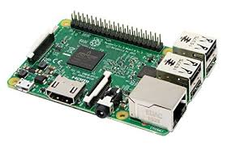

USB MIC :

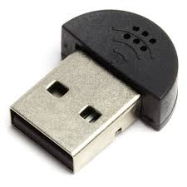

Speaker:

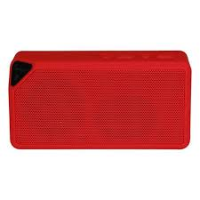

HDMI cable:

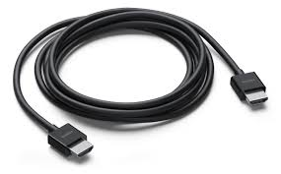

## Hardware Requirments:

A Raspberry Pi 3

A 32 GB micro SD card

A USB wall charger

A 3 Port USB Hub.

A USB Mic

Portable speaker with AUX input

A keyboard and mouse along with HDMI cable.

## Software Interfaces:

Amazon web server

Python idle

Google Assistant API

IFTTT Mobile Application

## Communications Interfaces:

For communication we are using internet,using Amazon’s developer console we will store information on cloud and according to query it will give response for example if we are asking where is our key it will give response that key is on the table and if any information requires Google’s help,it will extract information from Google and will respond to our query